Case Presentation: Odontogenic Infection with Systemic Signs

Chief Complaint
“Severe tooth pain and fever”
Differential Diagnosis:
- Odontogenic abscess with cellulitis
- Facial cellulitis
- Early deep space infection
- Mandibular osteomyelitis
Actual diagnosis: Odontogenic abscess with cellulitis /systemic infection
Opening statement: “ I have had bad pain in the top right in the past, mostly to hot and cold, last week it started to hurt when I chew and was throbbing, now I can't even touch the tooth, I feel weak and sick.”

History of Present Illness
You are a 21-year-old who presents to the emergency department with 7 days of worsening upper right dental pain, now associated with fever, facial swelling, and weakness. Enlarged lymph nodes
The pain began as a hot or cold pain, but now the pain is constant, severe, and throbbing.
On a scale of 0-10 (with 10 being worse) your pain is 8.
Over the past 24 hours, you have developed subjective fevers, chills, and fatigue, as well as increasing swelling of your right cheek area.
Chewing is painful.
You can open your mouth, but it's uncomfortable.
You are not drooling, you do not have voice changes, difficulty breathing, or inability to swallow liquids.
You have not seen a dentist since you lost your Medicaid last year. You think you have bad teeth. You think you might have seen some spots on your teeth that make you think you have untreated cavities.

Past Medical History
- General health is excellent; you are healthy and have no medical problems.

Medications
- Motrin or Advil 400 mg as needed every 6 hours
- You do not have a history of using opioids or any issues with opioid use or abuse
- You do not have any contraindications for using ibuprofen (Motrin or Advil)

Allergies
- No known drug allergies, you are not allergic to penicillin

Social History
- Tobacco: Smokes ½ pack per day
- Alcohol: Rare
- Illicit drugs: Denies

Physical Examination
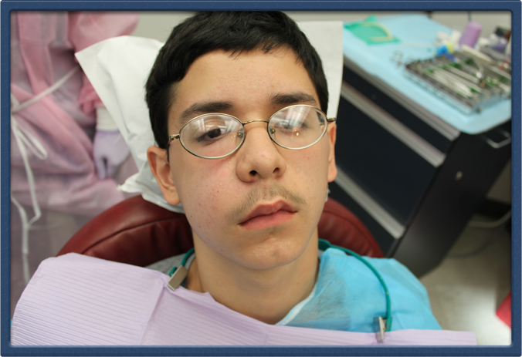
- Presentation/emotional tone:
- You will be sitting in a chair, in your normal clothes. Your right cheek feels puffy/ swollen. You are tired, you don't feel well, you feel sick, and you are uncomfortable. You can open your mouth with discomfort. The tooth that hurts is an upper right molar (back tooth). Your voice is normal.
Oral Cavity:
- The gums in the upper back right area of your mouth are red and swollen
- The gums in that upper back area are tender to touch (palpation) compared to other areas of the mouth
- Your back upper right tooth is very sensitive to touch, and it really hurts when tapping on it compared to other teeth

Emergency Department Management
The provider will order blood work and a CT scan to determine if you have an infection that they cannot see.
They might need to consult a specialist like an oral maxillofacial surgeon.
You might need to be admitted to the hospital.

1. Antibiotic Therapy
- IV ampicillin–sulbactam initiated in ED

2. Pain and Supportive Care
- IV fluids
- NSAIDs ± opioid analgesia
- Antipyretics
Ask the provider, “Will the antibiotic make the tooth better?”
The provider should tell you the following
- Pain will not improve without dental intervention
- Antibiotics alone are not a definitive treatment

Referral
- You need to see a dentist within 72 hours to receive dental treatment or follow the instructions of an oral maxillofacial surgeon.

Checklist:
- What was your experience like during this encounter with the provider using the clinical decision support tool for dental pain? Good/neutral/bad
  - Please explain (open-ended)
  - Did you feel worried that the provider was using a CDST? Why or why not? (open ended)
Answer Yes/No for the following questions
- Did the provider ask if you have a fever

- Did the provider ask if you are allergic to penicillin
- Did the provider ask if there is pain with cold?
- Did the provider ask if the pain goes away immediately or persists after removing the cold trigger?
- Did the provider ask if there is pain with biting/chewing/tapping the tooth
- Did the provider ask you if you have taken Advil/Motrin (ibuprofen) or Tylenol or antibiotic at home
- Did the provider offer you dental block, dental anesthesia, injection?
  - If yes, did they explain that it provides temporary pain relief
- Did the provider tell you that the antibiotics you received will not resolve the tooth problem?
